Olde Florida Golf Club
Assistant Golf Course Superintendent, Available Immediately
Designed by Rees Jones and opened in 1993, Olde Florida Golf Club is a distinguished private, individual-membership club located in Naples, Florida. Olde Florida is a golf-only facility that exists solely for the enjoyment of its membership. The club is recognized as one of the premier private clubs in Southwest Florida and beyond.
Situated on 220 acres, the 18-hole course provides a challenging yet enjoyable test of golf in a natural setting. Olde Florida is an established, invitation-only club with a multi-year waiting list for membership.
The club and agronomy team continually strive to enhance the golf course and facilities while improving all aspects of maintenance, operations, and management.
Olde Florida has had only one golf course superintendent, Darren J. Davis, CGCS, who was hired in 1992. During his tenure, Davis has helped advance the careers of dozens of turfgrass professionals who have gone on to leadership positions throughout the industry.
Among other accomplishments, Davis served as the 82nd President of the Golf Course Superintendents Association of America (GCSAA) and remains actively involved at the local, state, and national levels.
More information about Davis and Olde Florida can be found at: DarrenJDavisGCS.com
The individual we seek will possess a strong personality and skillset, but more importantly, a consistently positive attitude and a commitment to team culture. While there is never room for complacency within the organization, a healthy work-life balance is both encouraged and expected.
Personal character, leadership ability, and the willingness to put the team first will have a greater impact on success in this role than technical ability alone. Efficiency, attention to detail, strong time management, and a passion for the profession are qualities we value highly in the newest member of the Olde Florida agronomy team.
Under the direction of the Golf Course Superintendent, the Assistant Superintendent will help manage and supervise a dedicated staff of golf course maintenance professionals and assist in both daily course preparation and long-term improvement projects.

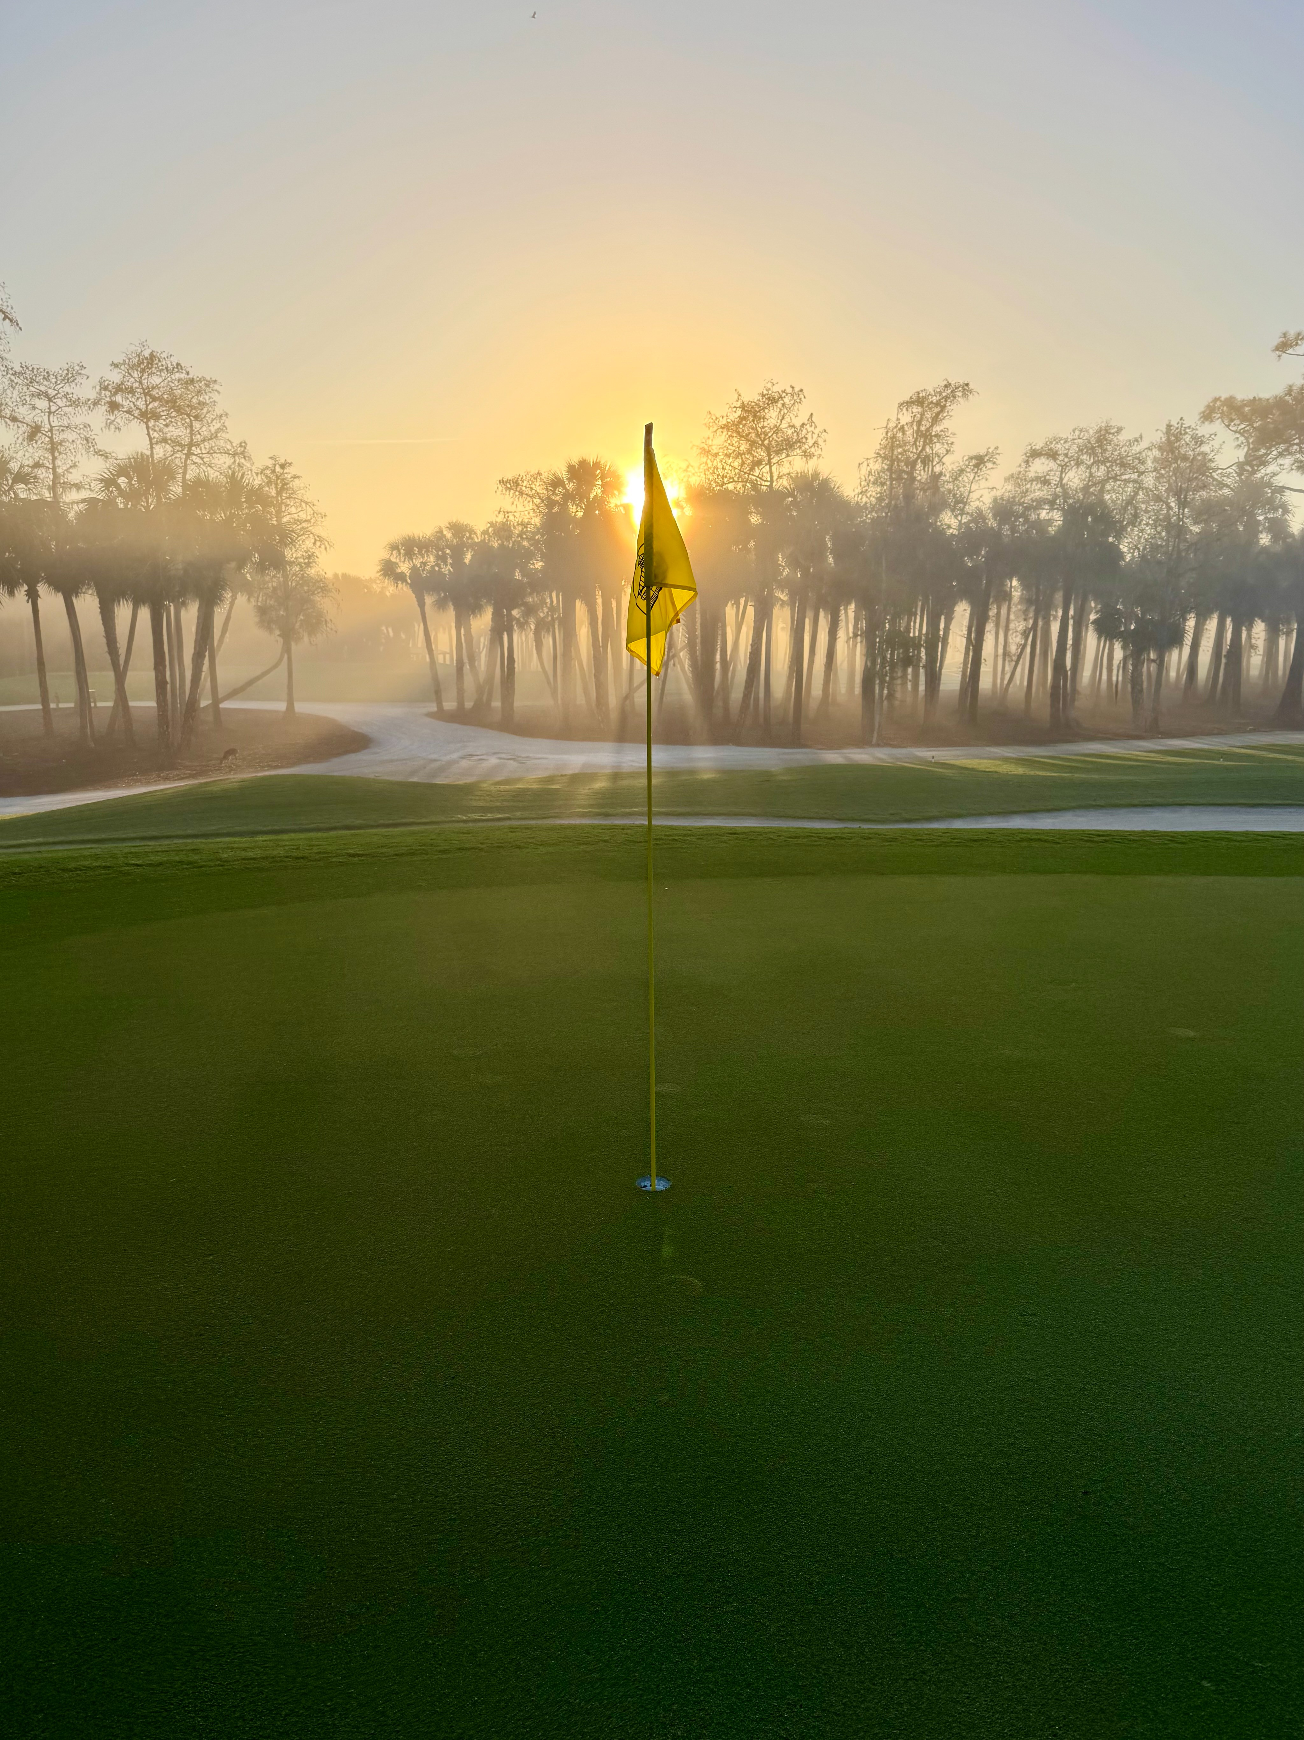

Essential Duties and Responsibilities

- Play a lead role in the daily preparation of the golf course for members and guests, including the maintenance of greens, tees, fairways, and roughs.
- Assist in planning and executing daily maintenance activities and long-term agronomic programs
- Train and mentor staff in all aspects of golf course maintenance, including proper operation, care, and storage of equipment
- Foster a positive working environment through leadership, communication, and attention to detail
- Assist in implementing and managing a comprehensive water management program, including irrigation setup, run time adjustments, hand watering, and syringing
- Maintain a strong commitment to safety in all maintenance areas, including the equipment shop, course operations, roadways, and chemical handling and storage
- Work closely with the Equipment Manager to ensure all equipment is properly cleaned, maintained, and stored
- Supervise and participate in fertilizer and pesticide applications, ensuring proper handling of materials, inventory control, and record keeping
- Maintain high standards of professionalism in staff appearance, course presentation, equipment care, and shop organization
- Assist in preparing and conducting morning staff meetings to communicate daily objectives and safety expectations

- Recommend purchases and assist with maintaining appropriate inventory levels
- Participate in continuing education opportunities to remain current with industry practices and innovations
- Communicate and collaborate with the golf professional staff regarding course conditions and daily operations

Supervisory Responsibilities
The Assistant Superintendent maintains a supervisory role in accordance with club policies and applicable laws and regulations. Responsibilities include assisting with recruiting, interviewing, and training staff, planning daily work schedules, and assigning duties.

Qualifications
- Strong communication, leadership, and coaching skills
- Ability to work collaboratively within a team environment
- Florida Department of Agriculture & Consumer Services Commercial Applicator License required (or ability to obtain after employment)
- Working knowledge of golf course conditioning, team leadership, equipment operation, water management, course construction, and professional development

Salary and Benefits
- Salary: $85,000 - $90,000, commensurate with experience
- Blue Cross and Blue Shield health care plan covered at 60%
- Safe Harbor 401(k) plan
  - 100% match up to 3% contribution
  - 50% match between 3% – 5% contribution
- Clothing allowance
- Association dues (regional, state, and national)
- Continuing education opportunities
- Meals
- Paid vacation
- AFLAC policies available
- Christmas bonus
- Cell phone reimbursement
- Golf privileges and employee discount on golf shop purchases

Education and Experience

- Degree in Turfgrass Science/Management or related field from an accredited college or university preferred, but not required.
- Minimum three years of golf course maintenance experience preferred, but not required.

Contact
Please send resume, cover letter, and any questions regarding the position to:
Darren J. Davis, CGCS DarrenJDavis@aol.com
(239) 353-4441
Olde Florida Golf Club
9393 Vanderbilt Beach Road Ext. Naples, Florida 34120

Why Work at Olde Florida
Olde Florida Golf Club offers a unique professional environment where individuals are encouraged to grow both personally and professionally. The club has a long-standing commitment to excellence, stability, and mentorship within the agronomy department.
The agronomy team operates in a culture built on respect, teamwork, professionalism, and pride in daily preparation. Team members are encouraged to develop leadership skills, pursue continuing education, and take ownership of projects that contribute to the long-term success of the golf course.
Olde Florida is committed to developing future leaders in the golf course management profession, and provides an environment where motivated individuals can learn, grow, and take on meaningful responsibility.
The club also values the importance of work-life balance, recognizing that maintaining passion for the profession requires time to recharge outside of it.
For an individual who is motivated, eager to learn, and passionate about the golf course management profession, Olde Florida provides an exceptional opportunity to build a career while working at one of Southwest Florida’s premier private clubs.

