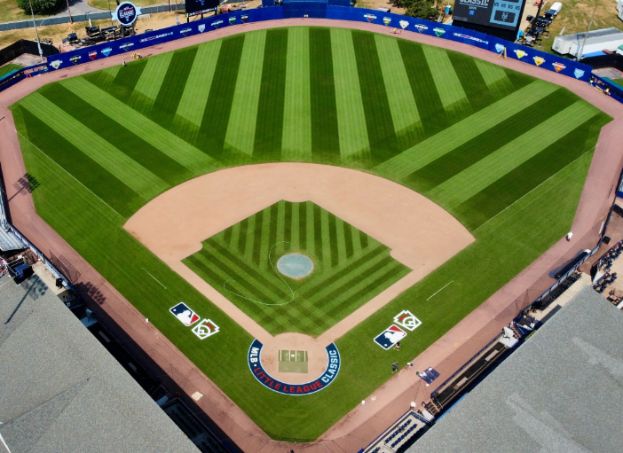
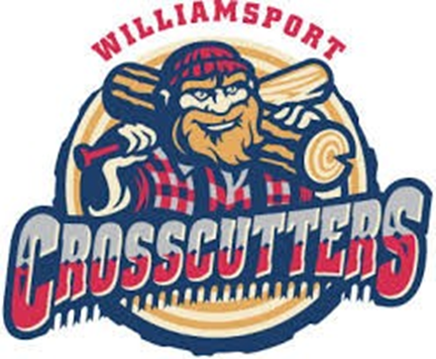

Grounds Crew Internship Position Announcement:
The Williamsport Crosscutters are looking for Grounds Crew interns for the 2026 season. The Crosscutters play at Historic Bowman Field in Williamsport, Pennsylvania and are a founding member of the MLB Draft League.
In Late August, Bowman Field will host the MLB Little League Classic game between the Milwaukee Brewers and Atlanta Braves.

Responsibilities:
- Assist the Director of Grounds in maintaining a baseball field to a high professional standard. The intern will be involved in all aspects of field maintenance.
- This position will provide:
- Hands on experience needed to have a successful career in the industry.
- A detailed understanding of how to maintain a professional baseball field.
- Ensure you will be involved with all aspects of maintaining a professional baseball field, to include budget, site specific IPM and Fertility programs, turf related calculations, etc.
- Seat time on all turf equipment, including reel mowers, aerators, and sprayers
- Firsthand experience on how to complete major and minor renovations, of the mound, plate, bullpens, and infield dirt including the operation of equipment that goes along with it.
- Future career opportunities.

Position Requirements:
- Must be positive and enthusiastic about working in the professional baseball industry
- Must be professional, courteous, and friendly when dealing with customers, fans, players and other staff members.
- Must have a willingness to work hard.
- Enrollment or completion of a turf management program preferred but not necessary.
- 40+ hours/week. Position requires some nights, weekends and holidays depending on event programming schedule.

Start Date: May (willing to be flexible with college class schedule)
End Date: End of August
Housing: Can assist with housing if needed.
Compensation: $1700 per month stipend (Subject to increase)
Contact: Drew Romanski, Director of Grounds
Phone #: (607) 738-2989
E-mail: Drew.Romanski@brightview.com

