2026 Philadelphia Eagles Grounds Crew Internship

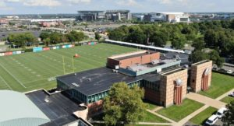

**Philadelphia Eagles**

**Description**

The Philadelphia Eagles are currently hiring for both summer and season long internships. The internship candidates will work directly with professional staff on a day-to-day basis and will assist in the preparation of all events at Lincoln Financial Field as well as the Philadelphia Eagles Training Facility. Lincoln Financial Field has a busy and exciting event schedule that includes

* Philadelphia Eagles Football games
* Temple University Football games
* 6 World Cup Soccer Matches
* Numerous Concerts
* Motocross and Monster Jam

**Essential Job Duties**

The ideal candidate will assist in all aspects of day-to-day field preparation and operations for Lincoln Financial Field and the Philadelphia Eagles Training Complex. You will be involved in all maintenance practices including but not limited to  mowing, fertilizing, spraying, aerating, topdressing, verti cutting, fraise mowing, and equipment maintenance. This unique internship offers great experiences of warm season grasses and transitions.

**Required Education and/or Experience:**

* Be enrolled in or recently graduated from a two or four-year Turf Management or Horticulture Program.

**Internship Benefits**

* Competitive wages with overtime available
* Uniforms are provided
* Meals
* Flexible start and ends date

**To Apply**  
Please submit a cover letter, resume and references to

Eddie Harbaugh

eharbaugh@eagles.nfl.com