Montreux Golf & Country Club
Summer 2023 Internship
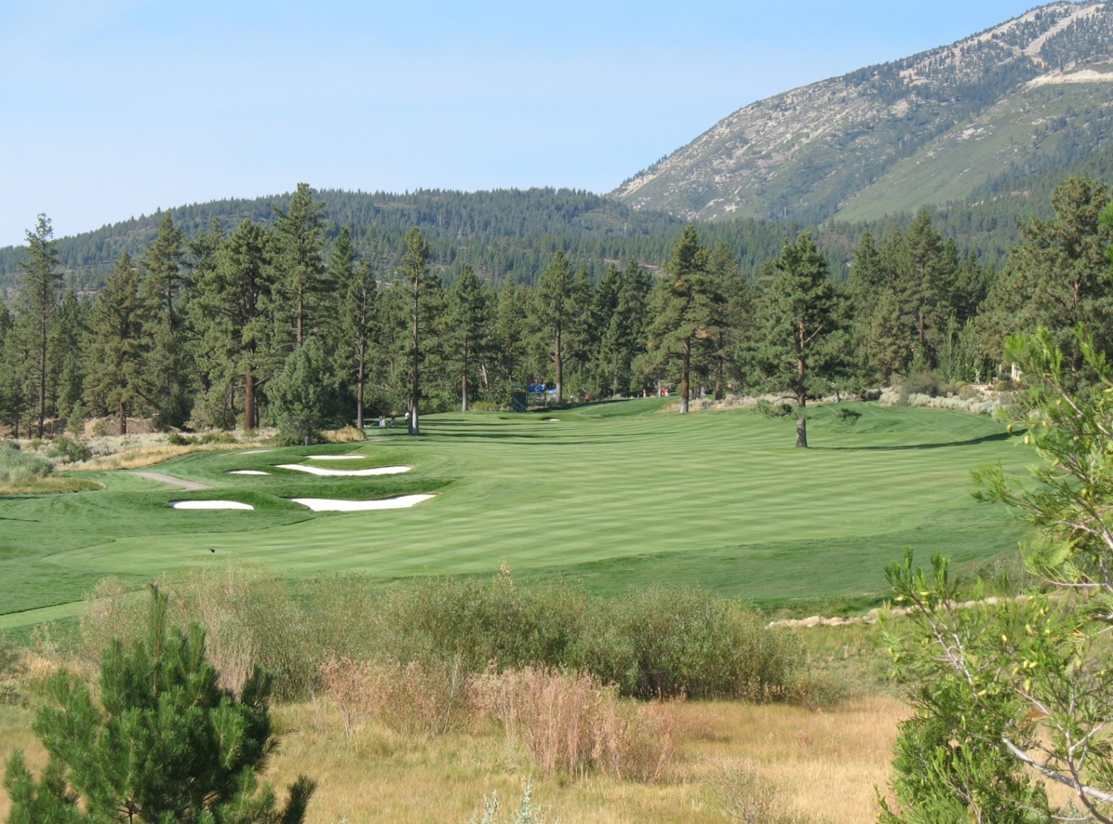

Montreux Golf and Country Club is a Jack Nicklaus Signature designed golf course located in Reno, Nevada. From 1999 to 2019, Montreux had hosted the Barracuda Championship, formerly the Reno-Tahoe Open. Originally grown in with bentgrass tees, greens, and fairways in 1998; Montreux is now nearly 100% Poa annua except for the Blue/Rye roughs. The high elevation, exceptionally clean water source, poor soils, and difficult to maintain turfgrass make Montreux an ideal place to grow your resume and gain valuable knowledge in the field of turfgrass management.
Montreux's location between Reno and Lake Tahoe, provides all the amenities of a small city with all the outdoor activities imaginable including, skiing, hiking, mountain biking, boating, fly fishing and more. Interns will receive a competitive wage, housing, golf, uniforms, lunch, and numerous opportunities for overtime. Montreux offers both three and six month internships so that interns may be involved in spring and/or fall aerification practices.
Interns will be an integral part of the management of the golf course, duties will include: Managing the chemical and fertilizer applications to greens, tees, fairways, roughs, and lakes; course set-up; assist with renovations of tees, greens, and bunkers; aid in management of personnel and small groups.
Requirements & Benefits:
Must be currently enrolled in accredited school seeking a Turfgrass management, horticulture, agronomy or other related degree. Job benefits we offer our interns are free housing/lunch/golf and the opportunity to gain immense knowledge and experience! Salary is $18.00/hr. for interns.
Please send Resume and Cover letter to blake@montreuxgolf.com.

