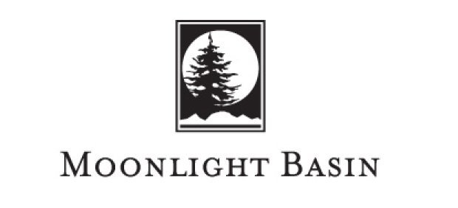

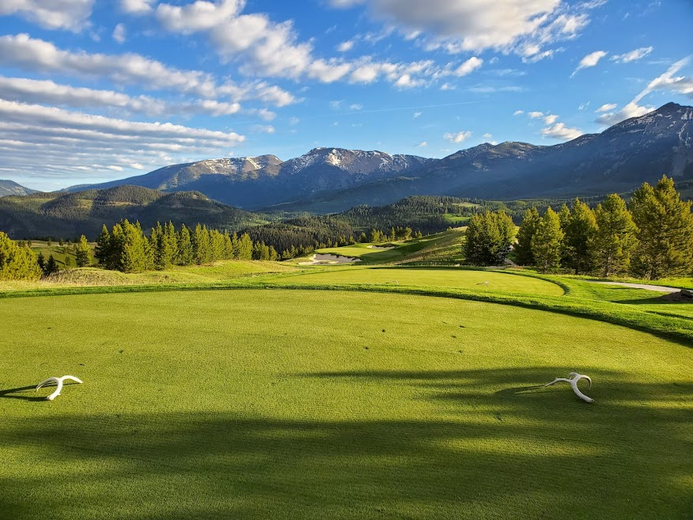

CONTACT:
Perk Purcell
Assistant Superintendent
mpurcell@moonlightbasin.com
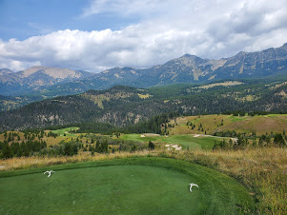
Located at 7,000 feet of elevation in beautiful Big Sky, MT, The Reserve at Moonlight Basin is a sprawling Jack Nicklaus Signature course that he considers to be the most beautiful he has ever designed. Stretching over 800 acres with 80 acres of maintained turf, our championship 18-hole course is situated on the open alpine slopes below the towering Rocky Mountains and provides panoramic views of the last best place. Opened in 2016 as the number 2 new course in the world and climbing quickly to the second ranked course in Montana according to Golf Digest we were chosen to host Capital One’s nationally televised celebrity pro-am “The Match” in July 2021.
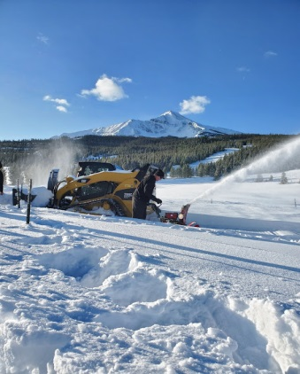
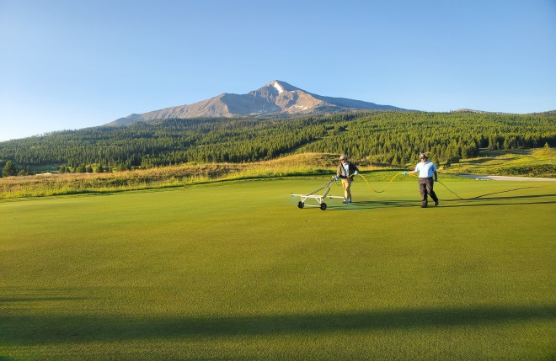
Our internship program takes into account every individual’s goals and focuses on what she/he wants to learn and improve upon. We will cover all aspects of golf course maintenance including operation and maintenance of all equipment, morning course set-up, and aerification and topdressing. We will dive into turf mathematics, sprayer and spreader calibration, granular fertilizer applications, chemical mixing and spraying of greens, tees and fairways. Our unique irrigation set-up has Rain Bird and Toro heads, offering our interns a chance to understand troubleshooting and repairs on both systems. The Reserve relies on a set water supply from snow melt ponds and leads to intense water management practices and nightly irrigation planning. We want to expose our interns to the responsibilities of supervisory positions and task them with leading small crews on sod, bunker and other projects to hone in their leadership skills.
We offer a once in a lifetime opportunity to learn about championship turf care in a uniquely beautiful setting with a personalized program and accept students with any experience level in the industry. Our benefits include no-cost housing, competitive wages, lunches, golfing privileges, and end of season bonus. We offer both three and six month positions with our six month program giving students the chance to see how we turn The Reserve from a winter wonderland to a championship course throughout the spring season.

