January 26, 2022

To Whom It May Concern:

We are glad to announce a new position at Tennessee Tech University. We are looking for a qualified greenhouse manager. Please circulate this ad to anyone you feel will be interested; we would like to speak to them.

Greenhouse Manager, Tech Farms, Tennessee Tech University. A complete position summary and application procedure is available at https://jobs.tntech.edu.
Application screening date: February 9, 2022; open until filled. Tennessee Tech is committed to a diverse workforce by fostering an inclusive work environment for students, faculty, and staff. Successful candidates should have a demonstrated commitment and contribution to fostering and advancing equity, diversity and inclusion. Tennessee Tech is an Equal Opportunity/Affirmative Action employer.

Thank you for your assistance helping us find the best manager possible.

Wings Up!
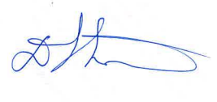
Darron L. Smith
Dean of College of Agriculture and Human Ecology
Tennessee Tech University
Cookeville, TN
darronsmith@tntech.edu

